Dashboard Design

Date
Team ID | MCA
Project Name | Smartphone Usage, Digital Addiction & Well-Being Analytics
Maximum Marks | 5 Marks

The dashboard for Smartphone Usage, Digital Addiction & Well-Being Analytics is designed to present smartphone usage, digital addiction, and well-being information in a clear and interactive manner. Power BI is used to create visualizations, filters, slicers, and interactive elements that help users understand important patterns in the data.
Activity 1: Interactive and visually appealing dashboards
The dashboard for Smartphone Usage, Digital Addiction & Well-Being Analytics is designed to present smartphone usage, digital addiction, and well-being information in a clear and interactive manner. Power BI is used to create visualizations, filters, slicers, and interactive elements that help users understand important patterns in the data.
- Clear and Intuitive Layout
- Use Appropriate Visualizations
- Colour and Theming
- Interactive Filters and Slicers
- Drill-Down Capabilities
- Responsive Design
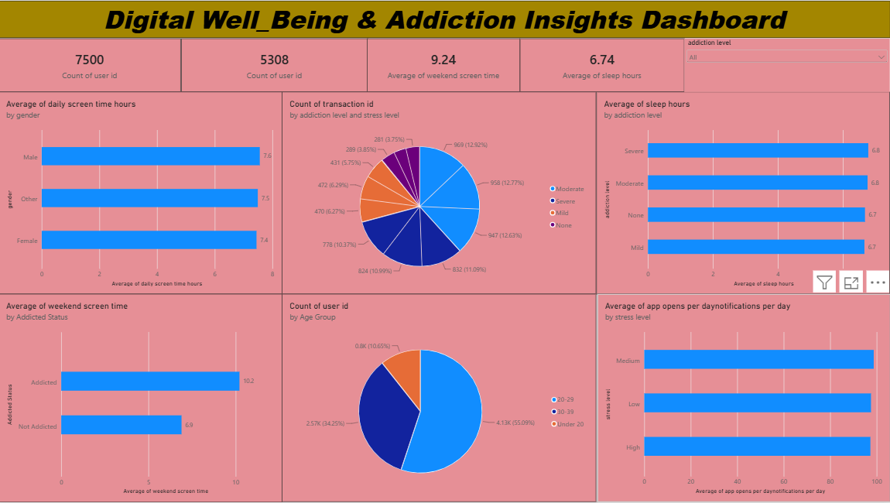
- Major Outcomes from the Smartphone Usage, Digital Addiction & Well-Being Dashboard:

- Total Users: The dashboard records 7,500 users, providing the overall user population analyzed in the project.

- Weekend Screen Time: The average weekend screen time is 9.24 hours, indicating substantial smartphone usage during weekends in the analyzed dataset.

- Sleep Duration: The overall average sleep duration shown on the dashboard is 6.74 hours.

- Addiction-Level Distribution: The dashboard shows 2.87K users in the Moderate addiction category (38.32%), 2.43K in Severe (32.45%), 1.37K in Mild (18.31%), and 0.82K in None (10.92%).

- Age-Group Distribution: The dashboard shows approximately 3.69K users aged 20–29 (49.23%), 2.57K aged 30–39 (34.29%), and 1.24K under 20 (16.53%).

- Screen Time by Gender: Average daily screen time is approximately 7.6 hours for Male, 7.5 hours for Other, and 7.4 hours for Female users.

- Weekend Screen Time by Addiction Status: The dashboard shows approximately 10.2 hours for Addicted users and approximately 7.0 hours for Not addicted users.

- Major Outcomes from the Smartphone Usage, Digital Addiction & Well-Being Dashboard
- The dashboard provides an overall understanding of smartphone usage patterns, digital addiction, and their relationship with users’ well-being. The major outcomes of the study can be summarized as follows:
- High smartphone usage: A significant proportion of users spend considerable time on smartphones every day, indicating that smartphones have become an important part of their daily routine.
- Digital addiction: The dashboard indicates varying levels of smartphone dependency among users. Some users demonstrate signs of excessive or habitual smartphone use, particularly through frequent checking and prolonged screen time.
- Purpose of smartphone use: Smartphones are primarily used for social media, entertainment, communication, education, online activities, and accessing information. Social media and entertainment can contribute substantially to overall usage.
- Difficulty controlling usage: Some users find it difficult to reduce their smartphone usage even when they intend to do so. This suggests the presence of problematic usage patterns among a section of users.
- Impact on daily activities: Excessive smartphone use may interfere with study/work, concentration, sleep, physical activity, and face-to-face social interaction.
- Effect on well-being: The dashboard highlights a relationship between smartphone-use patterns and aspects of users’ well-being. Higher levels of problematic use may be associated with reduced concentration, disturbed sleep, stress, or difficulty maintaining healthy daily routines.
- Awareness of digital habits: The findings emphasize the importance of users being aware of their screen time and developing healthier digital habits.
- Need for balanced smartphone use: The overall findings suggest that smartphones provide considerable benefits for communication, learning, and entertainment, but balanced and controlled usage is important to prevent negative effects on well-being.
- Overall Outcome
- The study concludes that smartphone usage is widespread among the users, with different levels of digital dependency observed across the participants. The dashboard helps identify patterns of excessive usage and their possible effects on daily activities and well-being. It therefore highlights the need for responsible smartphone use, regular monitoring of screen time, adequate sleep, physical activity, and maintaining a healthy balance between digital and offline activities.

